**Jenkins Task -1**

Launch jenkins and explore creating projects and users.

**Creating an Ec2 instance**

Instance type -> t2.micro

AMI -> Ubuntu

Security groups

SG1-> SSH, TCP, 22, Anywhere IPV4

SG2 -> Custom TCP, TCP, 8080(Jenkins default port), Anywhere IPV4

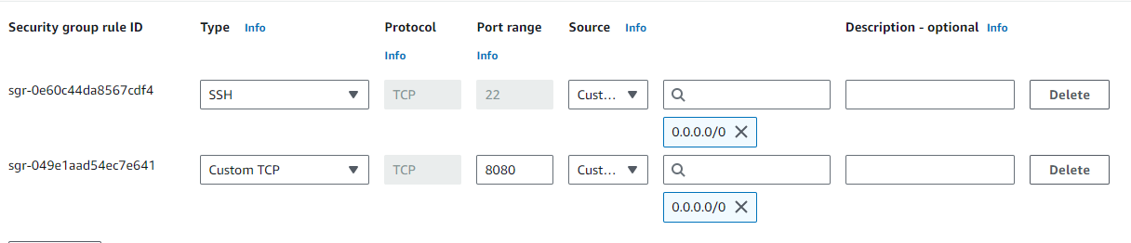

**Launching an Ec2 instance** -> ssh into it using ec2 public ip

**Install Jenkins:**

Below command is used to install Jenkins,

sudo -i (Be a root user)

apt update

sudo apt install openjdk-11-jdk

sudo wget -O /usr/share/keyrings/jenkins-keyring.asc \

https://pkg.jenkins.io/debian-stable/jenkins.io-2023.key

echo "deb [signed-by=/usr/share/keyrings/jenkins-keyring.asc]" \

https://pkg.jenkins.io/debian-stable binary/ | sudo tee \

/etc/apt/sources.list.d/jenkins.list > /dev/null

sudo apt-get update

sudo apt-get install Jenkins

1.Installation:

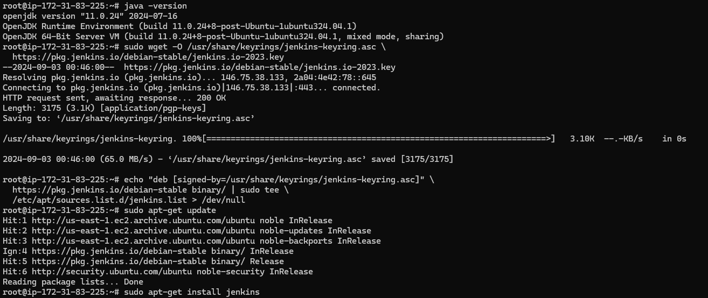

2. Jenkins status:

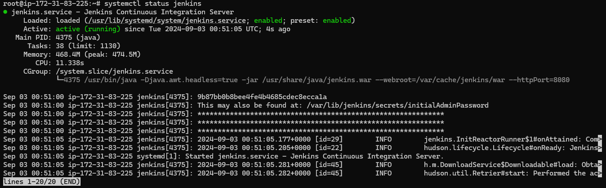

**Confiure Jenkins:**

Now launch chrome browser and <ec2inastance public ip>:port

* 98.81.240.11:8080

Provide the initial admin password, it can be get it by

* cat /var/lib/jenkins/secrets/initialAdminPassword

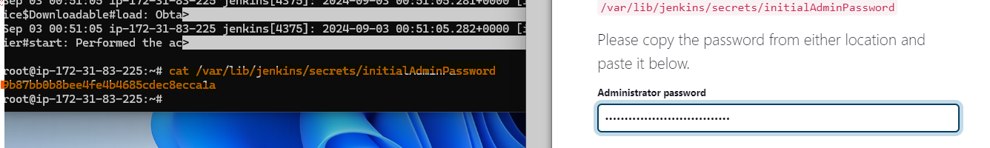

Install suggested plugins and creating an admin user 